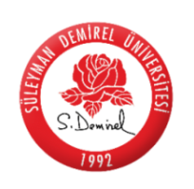

**SÜLEYMAN DEMİREL ÜNİVERSİTESİ**

**TÜRKÇE VE YABANCI DİL ÖĞRETİMİ**

**UYGULAMA VE ARAŞTIRMA MERKEZİ (SDÜ TÖMER)**

**2019-2020 EĞİTİM-ÖĞRETİM DÖNEMİ**

**AKADEMİK TAKVİMİ**

|  |  |  |
| --- | --- | --- |
|  | BAŞLANGIÇ  *(START)* | BİTİŞ  *(END)* |
| GÜZ DÖNEMİ | **07.10.2019** | **24.01.2020** |
| *FALL SEMESTER* | **7th October 2019** | **24th January 2020** |
| YARIYIL TATİLİ | **25.01.2020** | **02.02.2020** |
| *HALF TERM* | **25th January 2020** | **2nd February 2020** |
| BAHAR DÖNEMİ | **03.02.2020** | **11.06.2020** |
| *SPRING SEMESTER* | **3rd February 2020** | **11th June 2020** |